How to create a new folder/directory in filezilla

Login to your account

Be sure you are in the correct folder/directory, right click, left click on Create Directory.

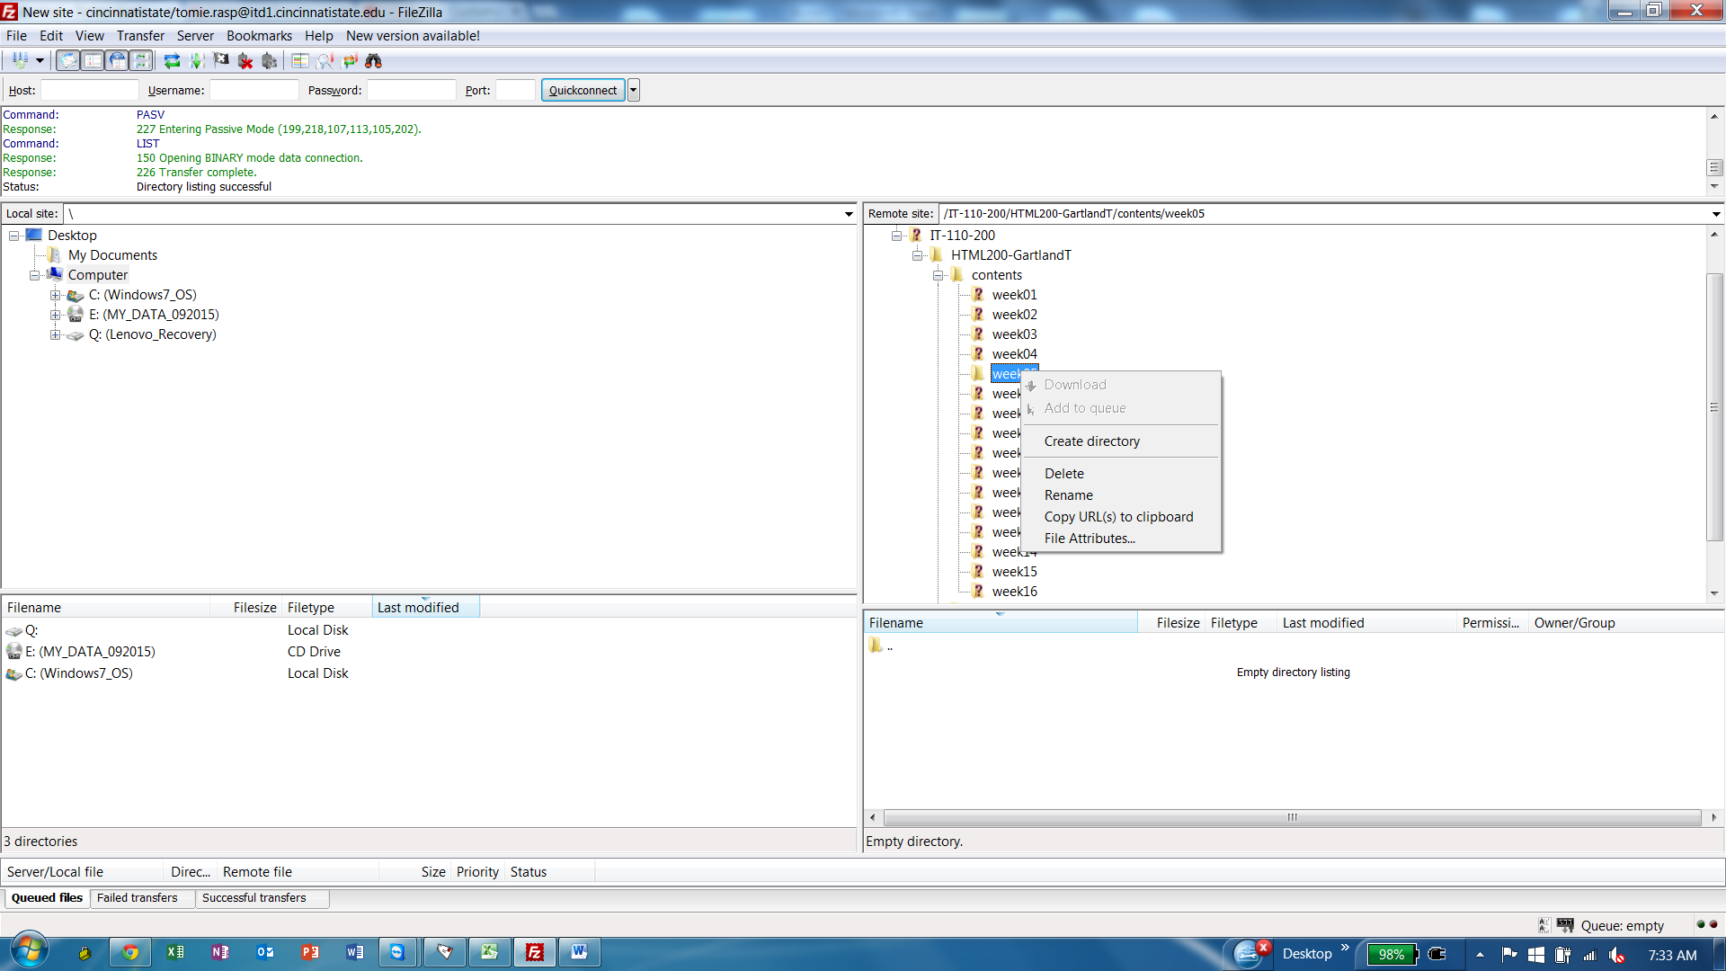

Type of ‘New Directory’ in the screen below:

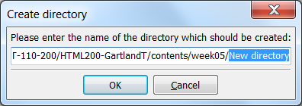

For example, type test1

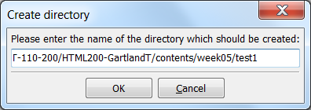

Now you will see the new folder in the week05 directory.

Be sure to notice the path above…this path will be part of your home page link.

Now, move all your files to the test1 directory.

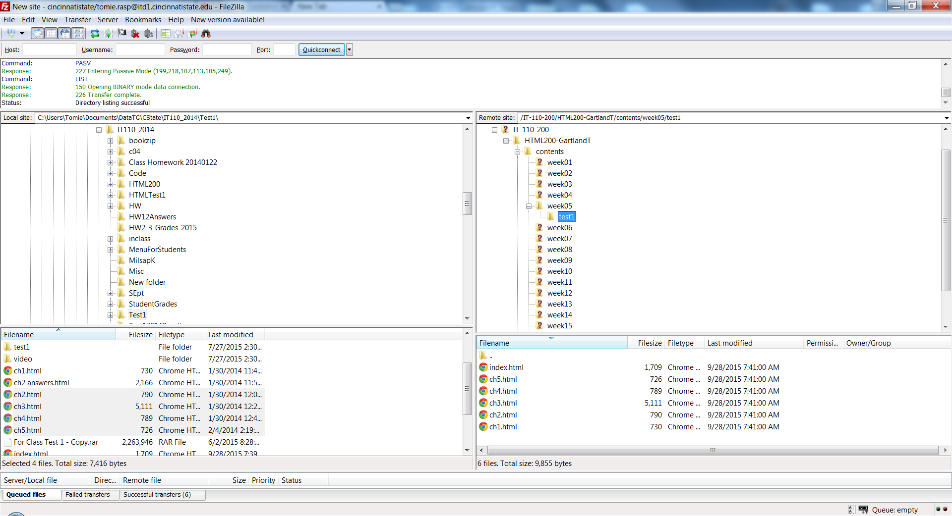

In order to test the links on the internet, you must enter the following link into the web browser address bar:

<http://itd1.cincinnatistate.edu/IT-110-200/HTML200-GartlandT/contents/week05/test1/index.html>

See how this matches the path when you created the new folder.

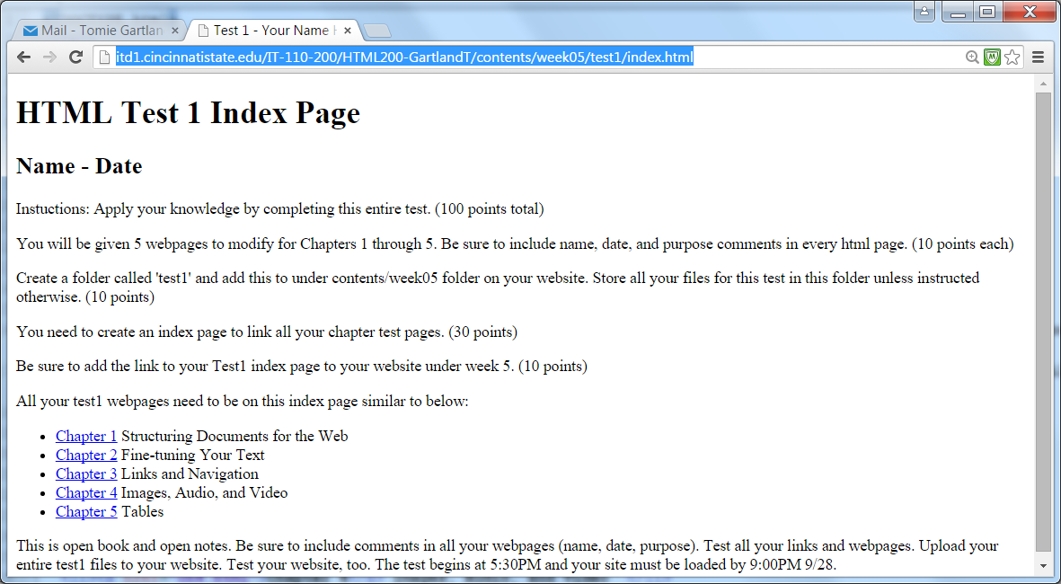

Now, you must modify your index page to point to the test1 index.

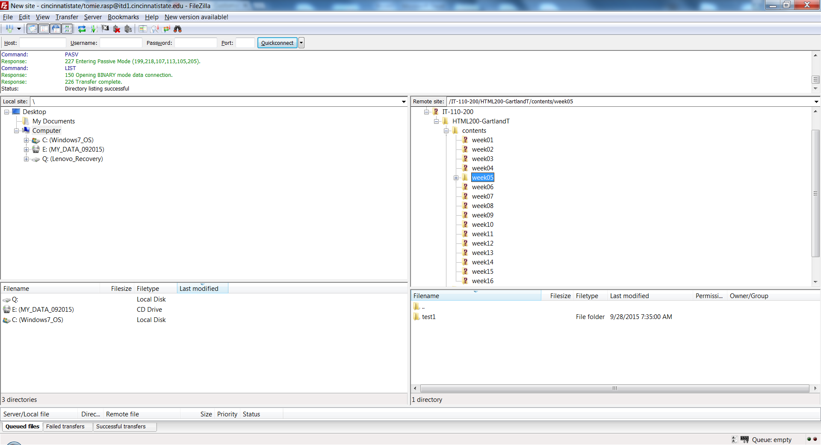

Add this line to your index page using NotePad++.

<a href = "contents/week05/test1/index.html" target="_blank"> TEST 1 </a>

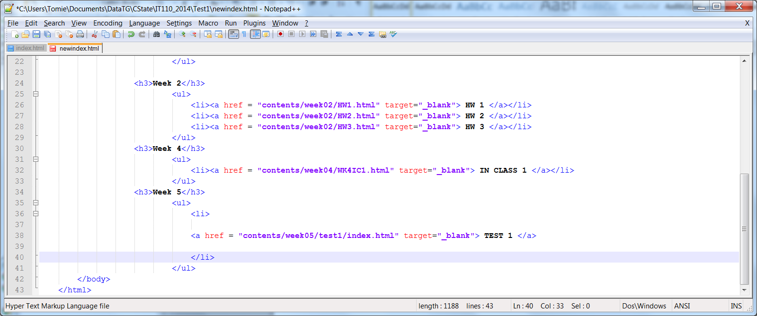

Upload your updated index page to your HTML200-LastnameF folder using FileZilla:

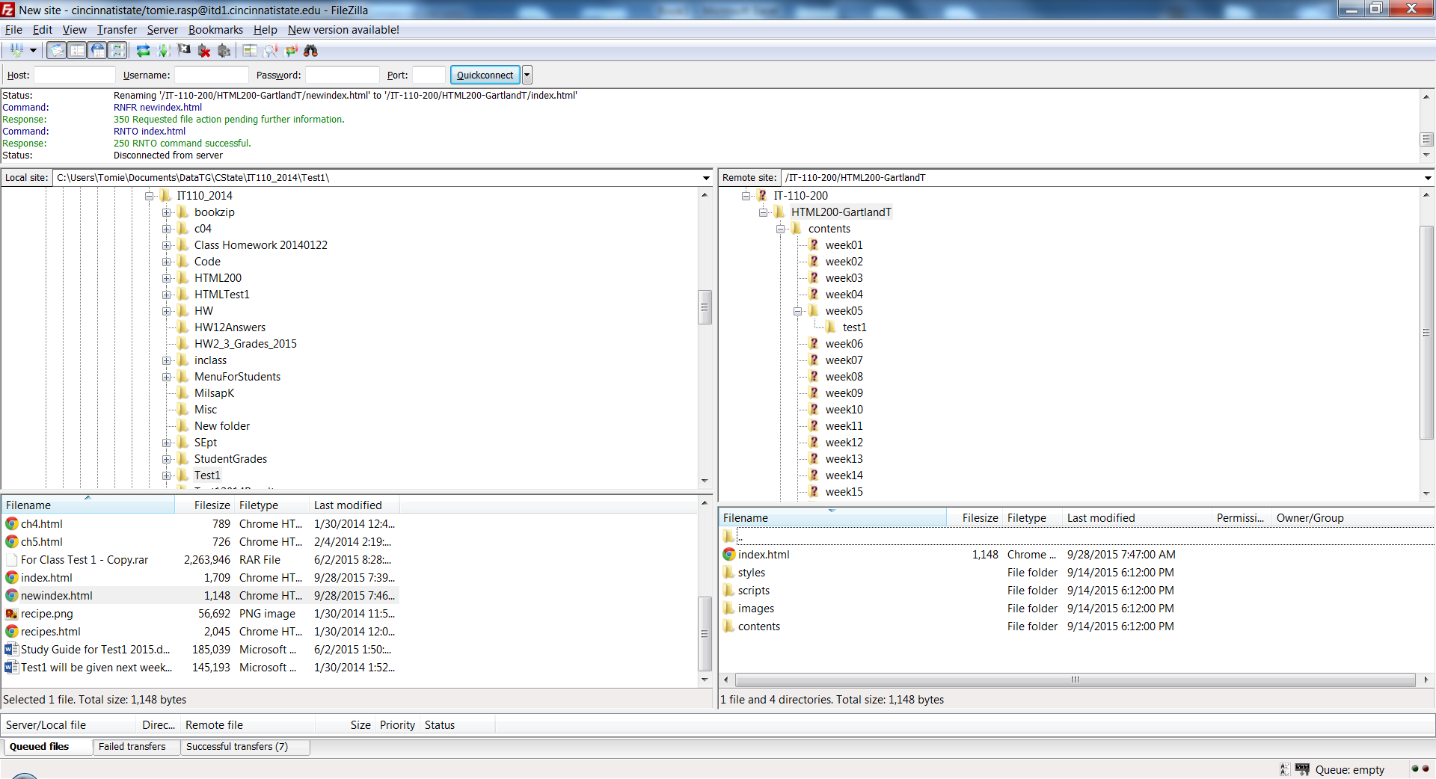

Test your work by typing your homepage link into the browser address bar:

<http://itd1.cincinnatistate.edu/IT-110-200/HTML200-GartlandT/>

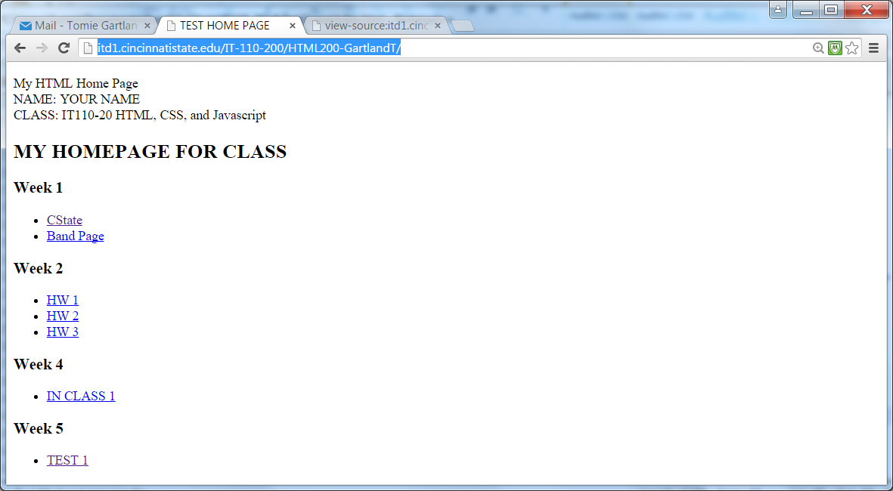

Now, click on the Test 1 link.

Notice this is the address where you loaded your work in the previous steps:

<http://itd1.cincinnatistate.edu/IT-110-200/HTML200-GartlandT/contents/week05/test1/index.html>

